**RESUME**

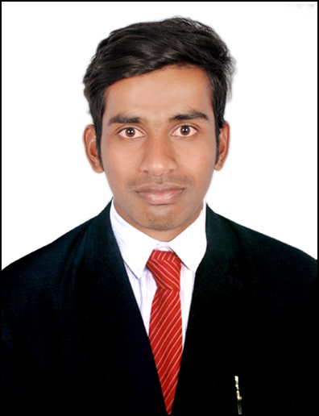

**MOHD KAREEM UDDIN**

**Email-Id: kareemcivil019@gmail.com**

**Mobile No: +91-904099986**

**OBJECTIVE**

**To work in a dynamic organization and utilize my skills and efforts for my personal as well as organizational success and growth by constantly attaining the niche skill set demanded by the roles in which I am working.**

**WORK EXPERIENCE**

**Excellent Associates** Oct-2020-Present

* **Organizing materials and ensuring sites are safe and clean.**
* **Preparing cost estimates and ensuring appropriate materials and tools are available.**
* **Providing technical advice and suggestions for improvement on particular projects.**
* **Authorizing technical drawings and engineering plans.**
* **Drawing up work schedules and communicating any adjustments to crew members and clients.**
* **Gathering data, compiling reports and delivering presentations to relevant stakeholders.**

**EDUCATION QUALIFICATION:**

* **B.tech ( Civil) from JNTUH, Hyderabad, India.**
* **Diploma (Civil) from state board technical education institute, Hyderabad, India.**
* **I.T.T (DRAUGTHSMAN CIVIL) from Industrial Training Institute, Telangana, India.**
* **SSC from Board of Secondary Education, Telangana, India.**

**.**

**TECHNICAL SKILLS**

* **PACKAGES Ms-Office (Ms-Word, Ms-Excel , Ms- Power Point),**
* **DESIGNING AUTOCAD**

**PERSONAL DETAIL:**

**Name : Mohd Kareem Uddin**

**Father Name : khatib moin uddin**

**Nationality : Indian**

**Language : English, Hindi, Urdu, Telugu**

**Driving License : Indian (2 & 4 Wheeler)**

Address : Hyderabad - INDIA